Warcraft II: Tides of Darkness, is a sequel to the real-time strategy game Warcraft: Orcs & Humans, developed and published by Blizzard Entertainment. Released in 1995 for MS-DOS and Microsoft Windows, it quickly gained popularity for its fast-paced gameplay, engaging story, and innovative features for the time.

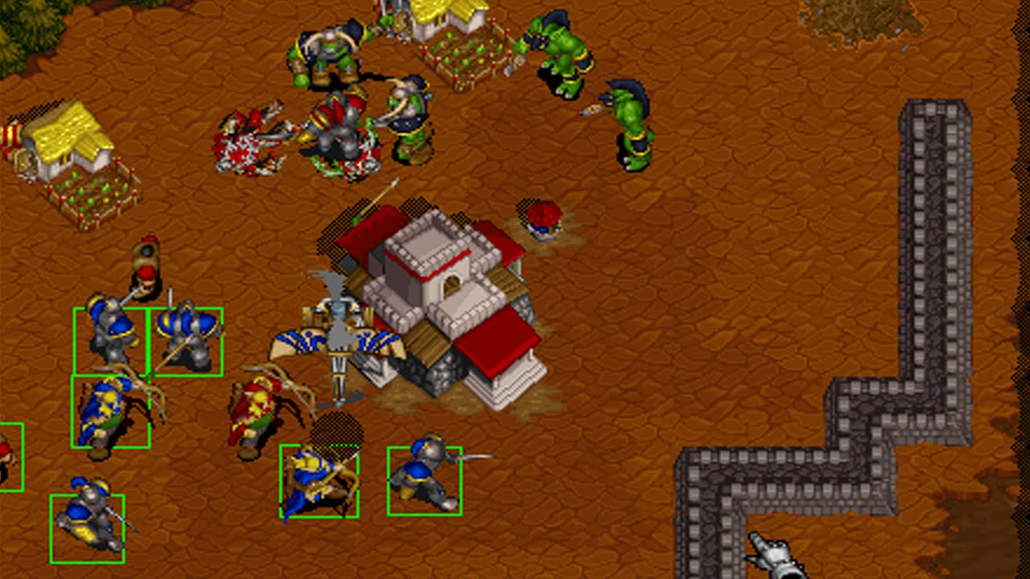

Warcraft II established the core gameplay mechanics that would become staples of the real-time strategy genre. Players choose a side – humans or orcs – and each side has its own unique campaign following the ongoing war between the two races. Players gather resources, construct buildings, train armies, and battle their opponents in a race to achieve victory.

The game was groundbreaking for its introduction of hero units – powerful characters with special abilities that could significantly impact the course of a battle. It also featured a fog of war system, which limited players' vision of the map unless they had units stationed in certain areas. This added a layer of strategy and suspense to the gameplay, as players had to scout their opponents' movements and be prepared for the unexpected.

Warcraft II was a critical and commercial success, selling over 1.5 million copies within a year of its release. It is considered to be one of the most influential video games of all time, having paved the way for future RTS titles like StarCraft and Command & Conquer.